Experiment No : 02

Experiment Name: Detection of radiation pattern of a directional antenna.

Introduction :
This document gives basic antenna definitions and discusses antenna concepts with a focus on the pros and cons of directional antennas.

THEORY :
Antennas are a fundamental component of modern communication systems. By definition, an antenna acts as a transducer between a guided wave in a transmission line and an electromagnetic wave in free space. Antennas demonstrate a property known as reciprocity, which is an antenna will maintain the same characteristics regardless if it is transmitting or receiving. When a signal is fed into an antenna, the antenna will emit radiation distributed in space a certain way. A graphical representation of the relative distribution of the radiated power in space is called a radiation pattern. The radiation pattern of the antenna is of principle concern when engineering a communications system. Let’s assume that a signal needs to be sent from an antenna on the ground to a satellite in orbit. This would require a radiation pattern with the majority of its radiated power focused into orbit. If the antenna is not engineered to do so, contact cannot be established between the signal source and its target. There are many different ways to manipulate a radiation pattern to meet the demands of a specific task. These concepts are the principle focus of this lab assignment. Implementing this lab assignment, students will examine the radiation patterns of several antennas by hands on field testing. Only the most fundamental antennas were chosen for this lab assignment. This allows us to see visually how the most common types of real-world antenna designs function.
Objectives :

- To plot the radiation pattern of Dipole Antenna in E & H planes on log & linear scales on polar and Cartesian plots.

2.To measure the beamwidth (-3 dB), front to back ratio, side lobelevel and its angular position, plane of polarization and directivity and gain of Dipole Antenna.

Required Components :
There are many components to an antenna system, including the parts of the antenna and the cabling used to connect then antenna to the radio.
1. Antenna element
2. Mounting bracket
3. N-type connector
4. Ground plan
5.Antenna trainer board (DL-2595 De Loronjo)
6.Metering output -DE LORONJO
7.Power supply -Dc 5297M
8.Directional Antenna

Procedure:

- Set up the apparatus as shown in Fig.1. Again the antenna for maximum meter reading and mark this position of the receiver antenna as 0°. Set the source at, say, 10 GHz. Use square-wave modulation if necessary, and tune the detector. Adjust the calibrated attenuator for a 30 dB attenuation and adjust the meter gain to produce half-scale deflection. Take care to kept the distance between the antennas sufficiently large so that they are in the far-field zone.
- Rotate the receiving horn clockwise, in steps of 5 or 100, to cover the main lobe and atleast the first sidelobe. At each position, adjust the calibrated attenuator to restore the half scale deflection on the meter and record the attenuator setting.
- Return to the position 0° and repeat for half scale deflection when attenuation is 30 dB. Rotate in steps of 5 or 100 in the anticlockwise direction and record the attenuator setting at each step to restore half scale deflection.
- Convert the attenuator readings to dB and plot the results.
- Plot the radiation pattern in the above manner for both E- and H-plane. Determination the beamwidth and level of the first sidelobe with repeat to the main lobe.

Observation Table :

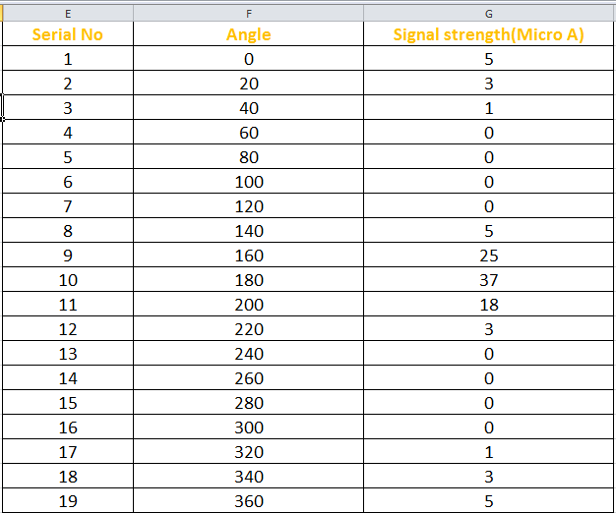

Source code for the antenna radiation pattern :

x=[0,20*pi/180,40*pi/180,60*pi/180,80*pi/180,100*pi/180,120*pi/180,140*pi/180,160*pi/180,180*pi/180,200*pi/180,220*pi/180,240*pi/180,260*pi/180,280*pi/180,300*pi/180,320*pi/180,340*pi/180,360*pi/180];
y=[5,3,1,0,0,0,0,5,25,37,18,3,0,0,0,0,1,3,5];
>> polarplot(x,y);

Output :

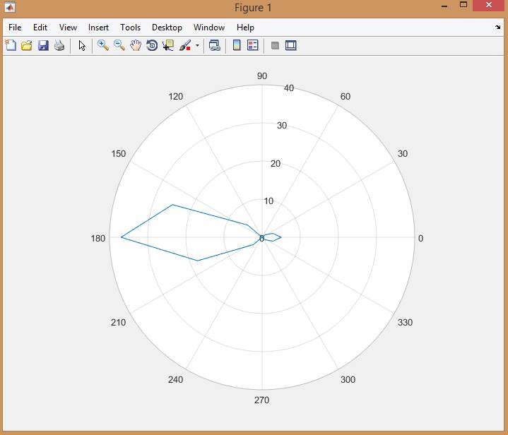

Precaution:
1.Connection and alignment of both antennas should be make carefully.
2.Reading must be taken carefully

Conclusion :
While directional antennas can be of great value for certain indoor applications, the vast majority of indoor installations utilize omnidirectional antennas for the reasons cited in this document. The selections of an antenna, directional should be strictly determined by a correct and proper site survey.

